Overview
Today’s tutorial introduces you to R, and suggests some best practices for writing readable, and reproducible code. We will use RStudio, an Interactive Development Environment (IDE) that wraps around R so you don’t have to use the terminal.

There are various file formats you typically use within RStudio. To start, we will use R Markdown, which generally refers to a document that is written in Markdown () with embedded chunks of R code. This website contains additional information about R markdown, which may come in handy later on: http://rmarkdown.rstudio.com/articles_intro.html

Learning Objectives
The instructions below will summarize how to set up RStudio, and guide you through an introductory tutorial using an R Markdown file. By the end of this tutorial, you will be able to:
- Navigate RStudio
- Understand the difference between R scripts and R Markdowns
- Print the current working directory, distinguish between absolute and relative paths
- Install and load libraries in R
- Load sample data, view the contents of a table, and manipulate the data using basic functions
- Save output to a directory of your choice
- Trace a workflow for debugging any issues you encounter

Supporting files required
- getting_started_with_R.pdf
- getting_started_with_R.Rmd
- sample_data_seminar0a.txt
GETTING STARTED: Installing RStudio and opening the RMarkdown file
- Install RStudio
  - Go to the following link and install RStudio for your Operating System.
    - https://www.rstudio.com/products/rstudio/download2/
    - Choose RStudio Desktop (Open Source License)
  - Open RStudio.
- Understand what you see
  - RStudio is comprised of various elements – the Editor, Workspace, Console, and Plots windows. The Editor lets you edit and save scripts, the Workspace tracks the data and values in R memory, you execute commands in the Console, and can use the Files/Plots/Packages/Help area to navigate dirs, view graphs, or use the help function.
Console: Execute R commands here
Make a new Rscript/Rmarkdown file, open an existing file
Navigate local directories, visualize graphs, track installed packages, search available documentation on installed packages and commands.
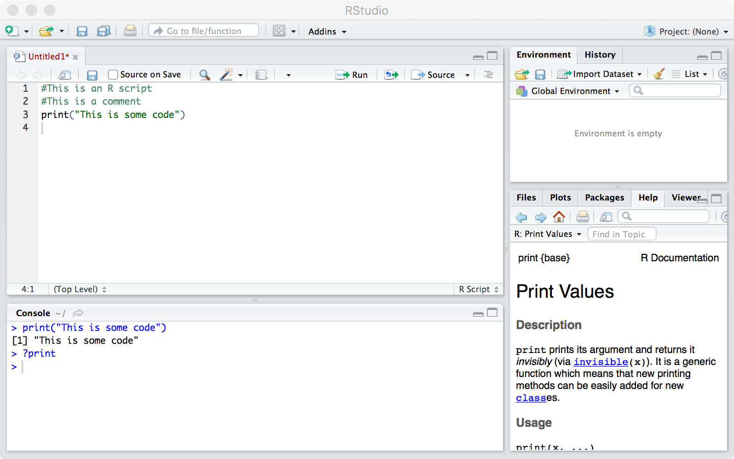
Editor

Plots

Workspace
- Playing around with the R Console
  - R is an interactive language. This means that you type a command, press Enter to execute it, and see the result (if there is anything to print from your command).
  - In the code above, we have run the command ‘print(“This is some code”)’ in the console, and can see the output immediately.
- Open the R markdown document for an introduction to RStudio
  - For the remainder of this tutorial, the code and supporting explanations have been put together for you in an R Markdown. An R Markdown lets you lets you generate reproducible, readable reports (like the one accompanying this guide!), conveniently and dynamically. You can 'knit' a .Rmd file into an html document, a pdf, a word doc, or an intermediate markdown file - without having to use a fancy converter.
  - In the Seminar0a folder, you should see 2 files:
    - getting_started_with_R.Rmd
    - getting_started_with_R.pdf
  - You can open the .Rmd file in RStudio, or just follow along with the .pdf document.
    - If this is your first time using R, we suggest you read through getting_started_with_R.pdf to familiarize yourself with the overall outline first.
    - You will see something like the following when you open the .Rmd file:

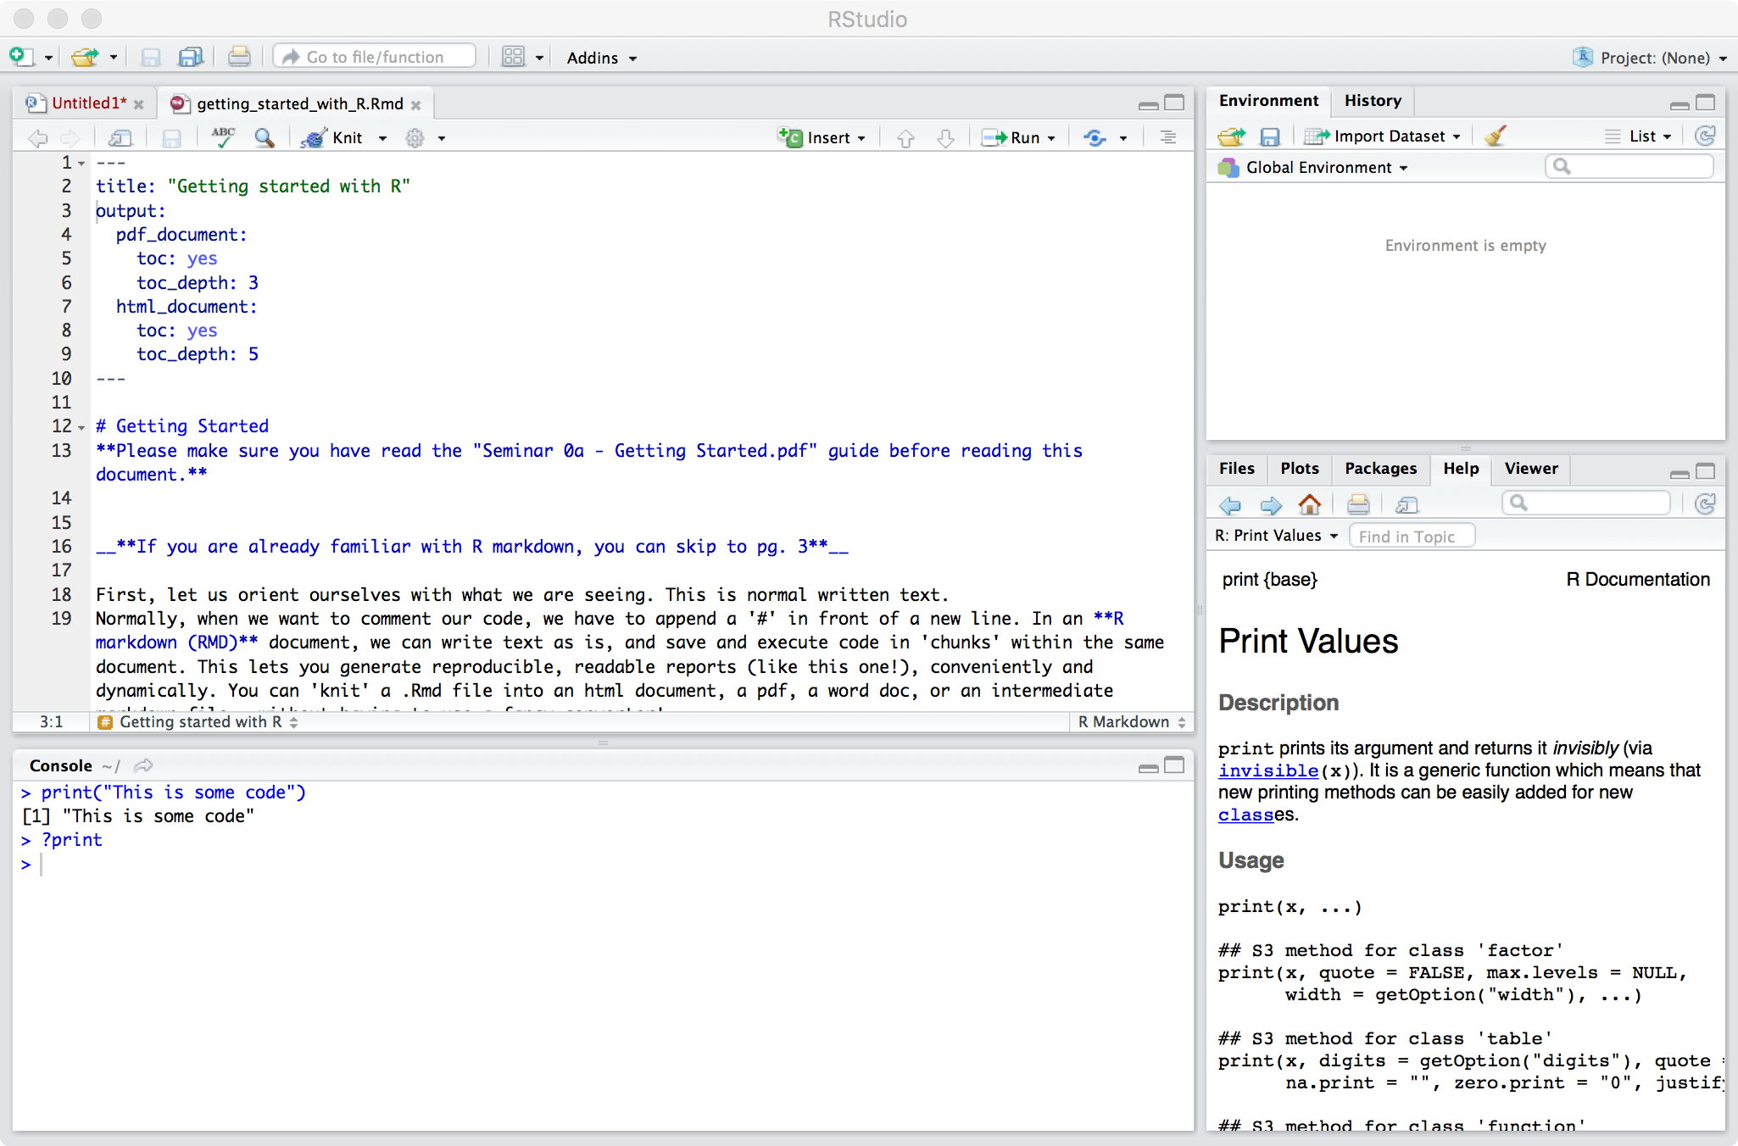

- Run code within the R Markdown
  - You can run a chunk of code by clicking in the area and selecting the option ‘Run Current Chunk’. You can compile the entire document in different output formats using the ‘knit’ option.
You can also ‘knit’ the entire document into a pdf/html/doc format, using this option
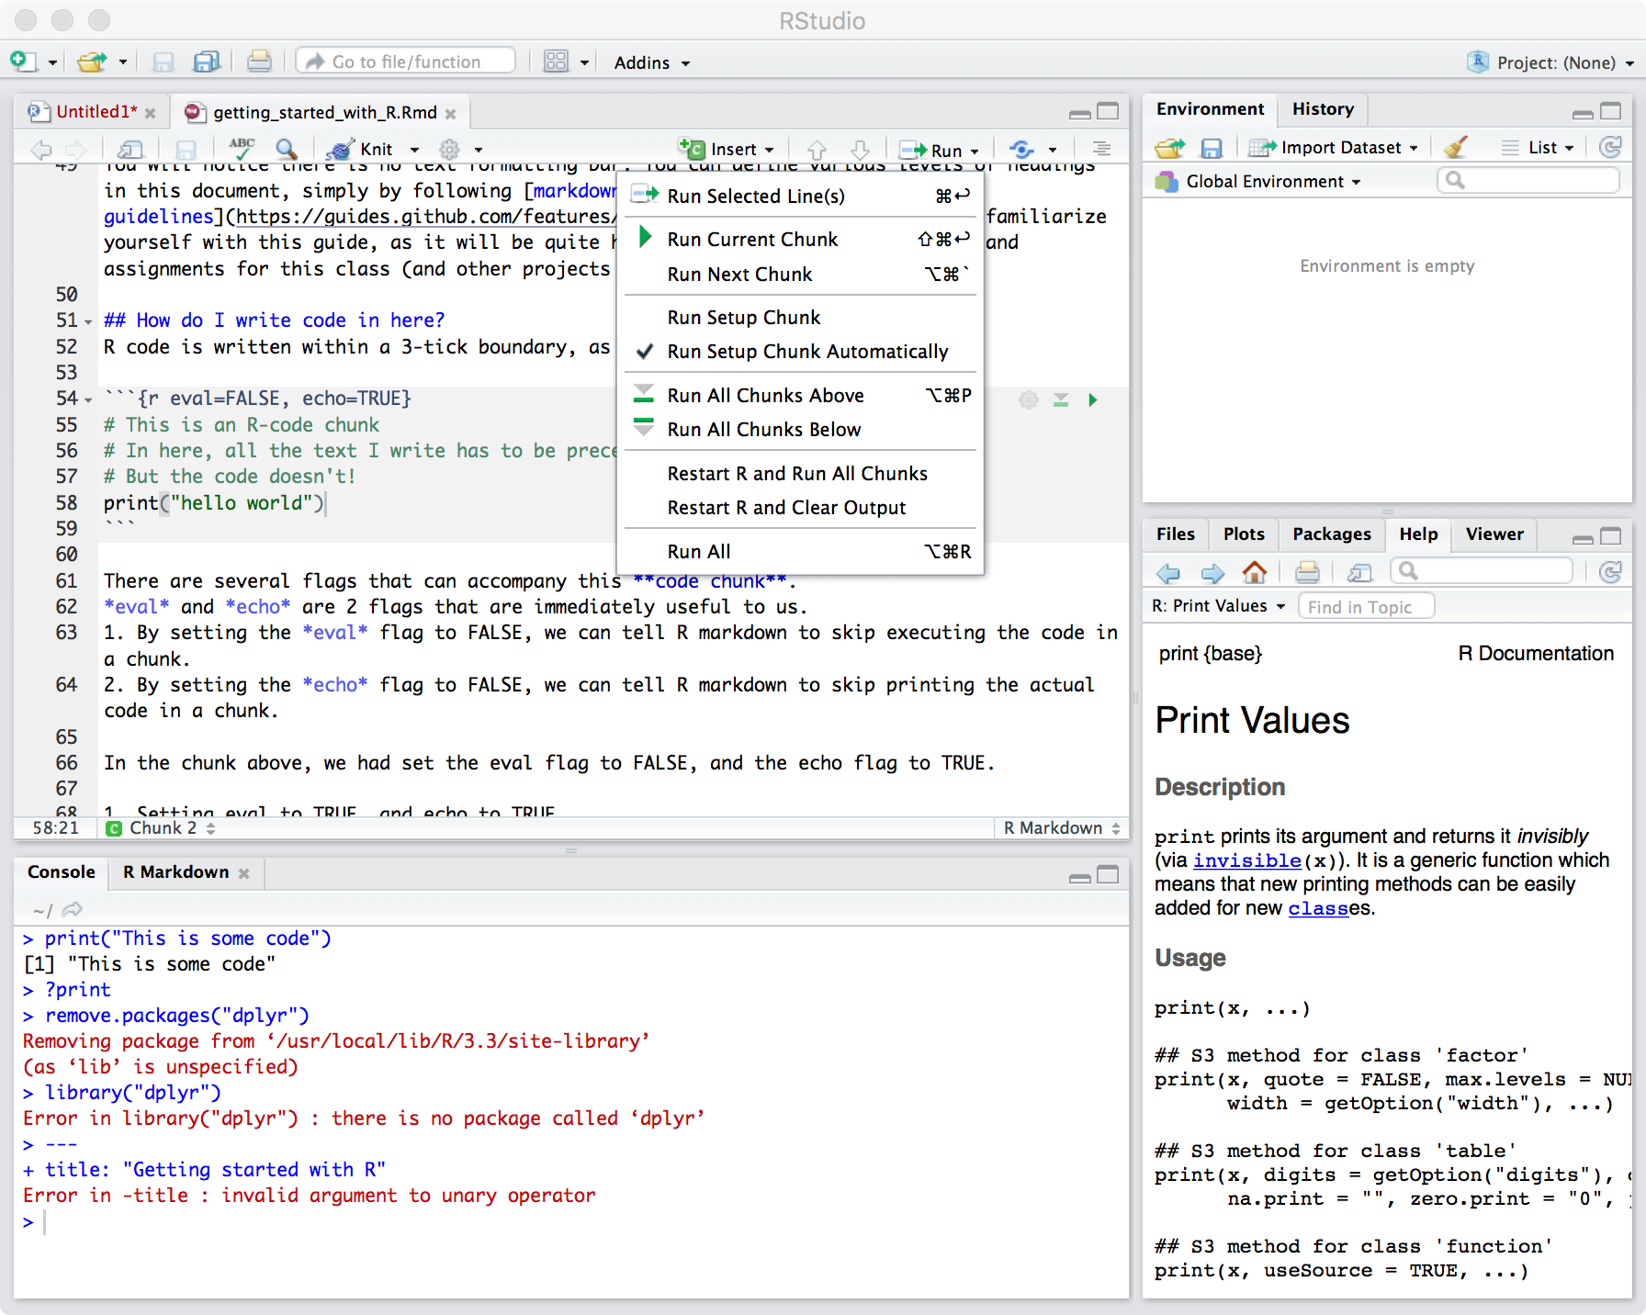
Click here to run the chunk
Navigate cursor to code chunk
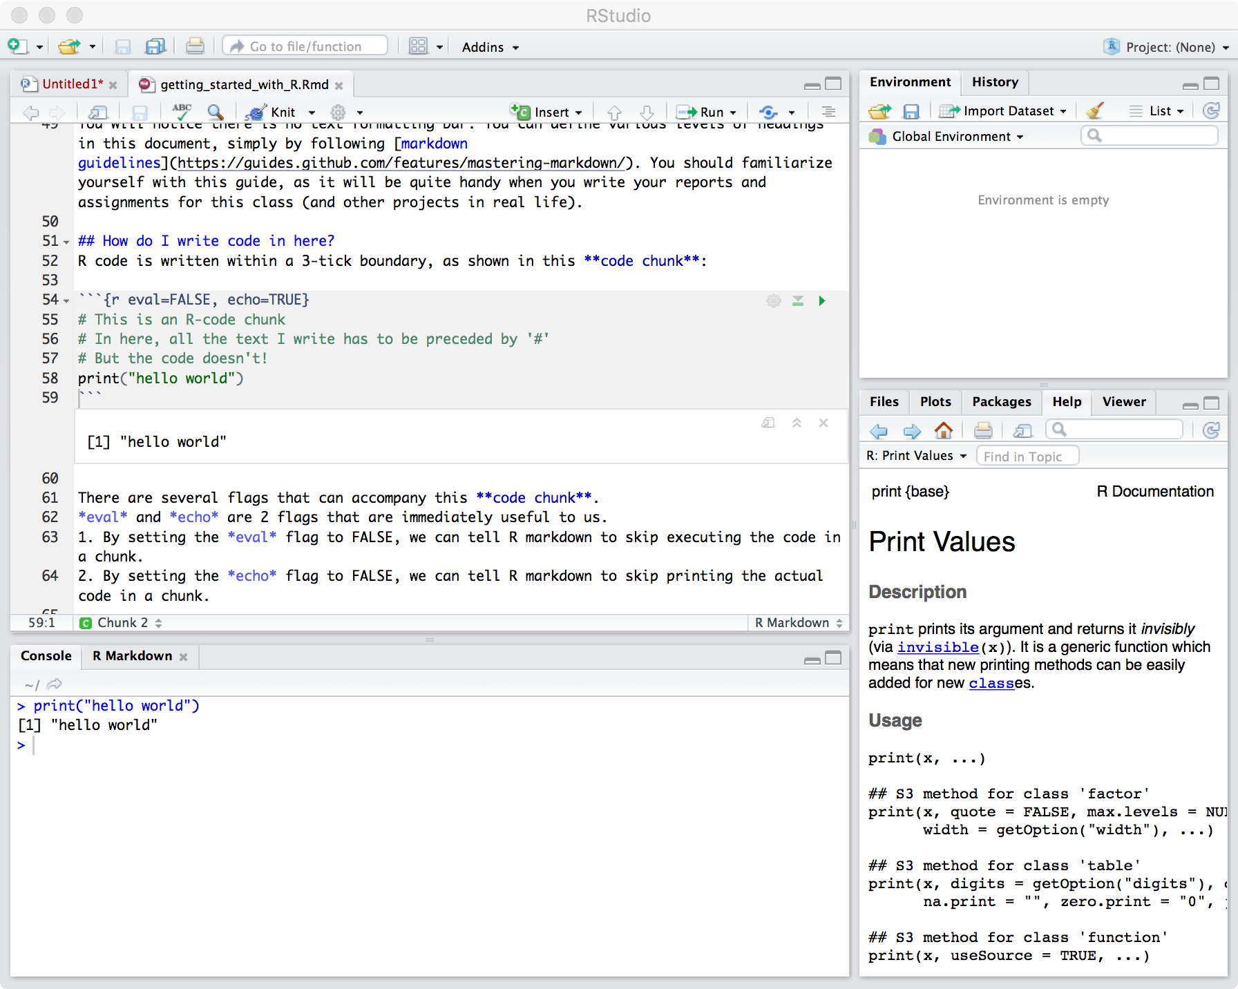
The output from running the code is shown both in the console and within the .Rmd file

